Towards a better understanding of the infestation of poisonous weeds in the rangelands of China

- Fellowship details
Grantee: Dr. Wei He
Address:
Department of Biology, Northwest University
229# North Taibai Road, Xian, Shaanxi, China, 710069
Tel: +86 18092662219
Email: hewei.scu@gmail.com
Visiting period: 20. Nov. 2017- 19. May. 2018 (extended to 19. Nov. 2018 by having reported to the secretary Mike Steele by emails)

- UK host organization
Professor Luis Mur and Dr. John Scullion
Institute of Biological, Environmental and Rural Sciences
Aberystwyth University
Aberystwyth, SY23 3FL, UK
Tel: +44 (0) 1970 622981
Email: lum@aber.ac.uk

- Purpose of the visit
- Identifying the effective antiseptic and insect-proofing compounds in weed Stellera chamaejasme L. based on the high throughput screening platform
- Carrying out collaboration including drafting research papers and proposals
- Establish formal links between Aberystwyth University and Northwest University

- Outcomes:

Variation in soil fungal composition may facilitate the invasion of Stellera chamaejasme L. in Qinghai-Tibet Plateau grassland
Background: Stellera chamaejasme L. is a native perennial herbaceous plant of grasslands in China. Its remarkable acclimation ability enables it to occupy a wide range of grassland types and climates, spanning the northeast to the southwest of China. In the grasslands of northern and western China, it has become an increasingly common weed. It causes a deterioration of the grazing resource due to its unpalatability to herbivores and has become the most problematic weed in China’s grasslands, threatening the viability of pastoral farming in affected regions. Once established, it tends to persist given its avoidance by grazing animals. most problematic weed in China’s grasslands.
Based on previous studies, the root exudates of S. chamaejasme affect co-occurring plants and thus may also affect soil fungi. Therefore, in this study, by employing a large-scale sampling strategy, we aimed to answer the following questions:
(1) Do soil fungal communities and edaphic properties differ between S. chamaejasme invaded and uninvaded sites?
(2) Does S. chamaejasme abundance or edaphic conditions explain variations in fungal communities?
(3) Are there differences in functional groups or particular fungal species that might relate to the presence of S. chamaejasme?
Methods: Soils (0–20 cm depth) on two adjacent sites, one invaded the other uninvaded, were compared for a range of physiochemical parameters and by DNA sequencing of fungal communities. At the invaded site, relationships between S. chamaejasme abundance, soil physiochemical factors, and fungal communities were further investigated to determine whether these relationships corroborated conclusions on the basis of site differences that could be translated into functional variation.
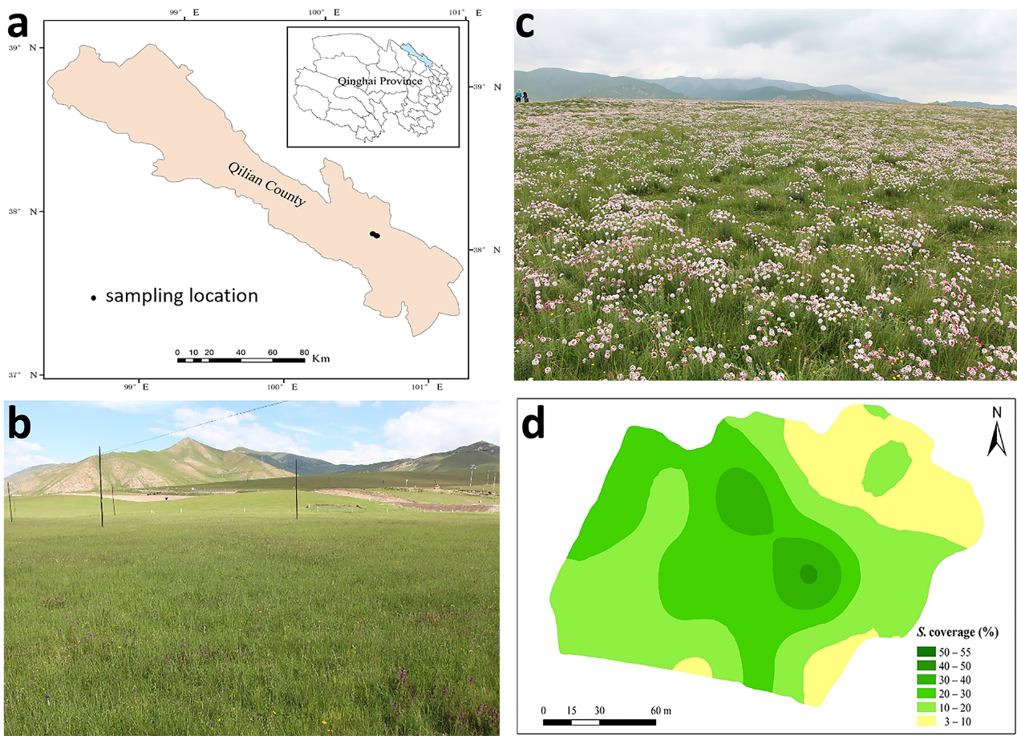
Figure 1. Sampling location in Qilian County on the Qinghai–Tibetan Plateau; (b,c) uninvaded and invaded sites; and (d) S. chamaejasme coverage on the invaded site.

Results: Based on our data we have the following findings:
- The invaded soils had lower N, P, organic matter, fungal alpha diversity, and relative abundance of arbuscular mycorrhizal fungi (AMF) (Table 1 and Table 2).
Table 1. Total soil nutrient and moisture contents (mean ± standard error)
 | Uninvaded | Invaded | P value
% K | 1.96 ± 0.016 | 2.02 ± 0.017 | 0.0487
% P | 0.06 ± 0.001 | 0.05 ± 0.002 | 0.0042
% N | 0.29 ± 0.043 | 0.22 ± 0.015 | 0.0009
% OM | 5.72 ± 0.217 | 4.02 ± 0.287 | 0.0002
C:N ratio | 11.4 ± 0.081 | 10.7 ± 0.089 | <0.0001
% H₂O | 26.8 ± 0.816 | 28.2 ± 0.514 | 0.136
pH | 7.85 ± 0.061 | 7.98 ± 0.082 | 0.176
C = carbon, N = nitrogen, P = phosphorous, K = potassium, OM = organic matter

Table 2. Population diversity indices and percentage of fungi OUT identified to phylum level (mean ± standard error). Significant differences (P<0.05) between the uninvaded and the invaded site were indicated by different letters.
 | Uninvaded | Invaded
Population diversity indices
OTU Count | 265±8.38a | 192±7.08b
Inverse Simpson Index (OTU) | 21.36±1.72 | 17.58±1.42
Shannon Index (OTU) | 3.85±0.06a | 3.57±0.08b
% Fungi identified to phylum
Ascomycota | 51.85±1.87b | 63.36±2.09a
Basidiomycota | 23.78±1.89 | 19.35±1.80
Zygomycota | 16.8±0.99a | 12.8±1.14b
Glomeromycota | 1.44±0.12a | 0.49±0.05b
Chytridiomycota | 0.29±0.05 | 0.22±0.09
Unclassified Fungi | 4.06±0.92 | 3.22±0.54
Fungi unidentified | 1.70±0.43 | 0.54±0.14

- The invaded and uninvaded soil differs in fungal beta diversity (Figure 2 and Figure 3). The differences can further be reflected functionally in the abundance of pathogens and beneficial fungi (AMFs). S. chamaejasme may actively accumulate pathogens and reduce AMFs to suppress the growth of other plants after its infestation (Figure 4).
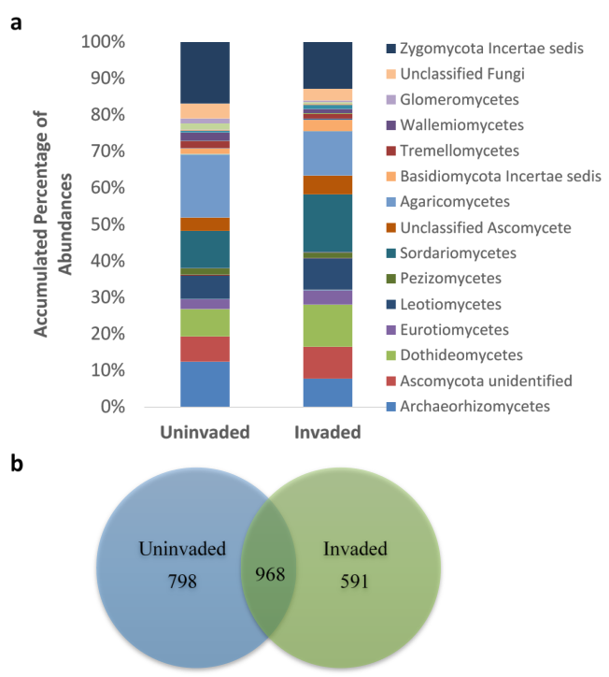
Figure 2. Class level differences (a) in mean % relative abundances and Venn diagram of assigned OTU (b) between the two sites
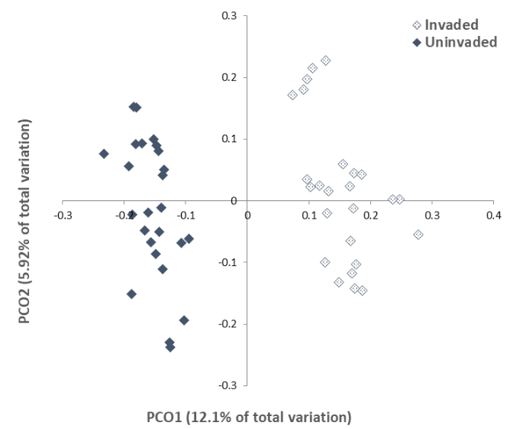
Figure 3. Principal coordinate ordination (PCO) of soil fungal communities in invaded and uninvaded grasslands (25 samples VS 25 samples), showing a clear separation between the two communities (PERMANOVA Pseudo-F = 7.9509, P = 0.001; ANOSIM R = 0.509, P = 0.001)

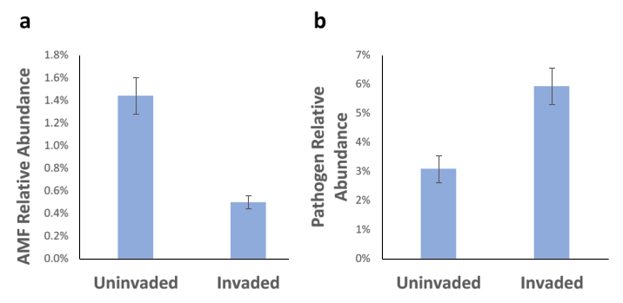
Figure 4. Differences between high level functional groups a) Arbuscular mycorrhiza (P<0.001) b) pathogens (P=0.003). Error bars represent SEM.

- Organic matter and P were the edaphic factors most strongly linked to site differences in total fungal communities (Figure 5). This agrees with the identification of specific fungi with P mobilization (Table 3).
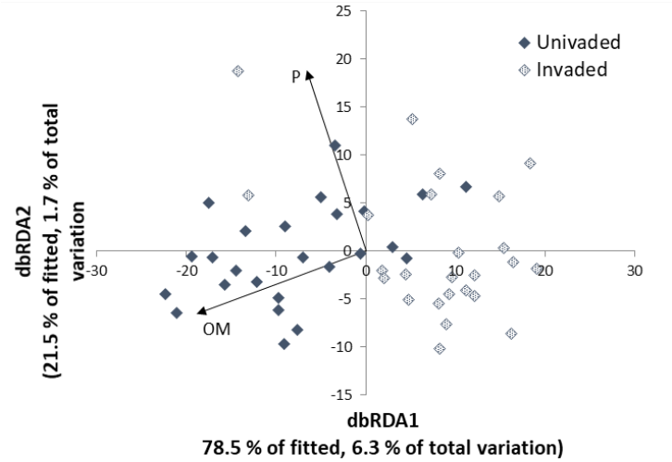
Figure 5. Plot relating fungal populations to soil parameters differentiating uninvaded and invaded sites. Of the parameters measured, only percentage total phosphorous and organic matter showed a significant correlation with fungal community composition (P < 0.01).

Table 3. SIMPER analysis showing 10 species contributing most to the dissimilarity (25.16%) between the two sites. Av.Ab: Average abundance, Av.Di: Average dissimilarity, Av.Diss: Dissimilarity, Diss/SD: standard deviation, Contr%: contribution to the observed dissimilarity, % of total, Cum.%: cumulative contribution %.
Species | UNITE SH ID | Uninvaded Av.Ab | Invaded Av.Ab | Av.Di | Diss/SD | Contr% | Cum.%
Archaeorhizomyces sp. | SH197151.06FU | 7.86% | 6.55% | 5.14 | 0.93 | 6.52 | 6.52
Mortierella sp. | SH211066.06FU | 4.28% | 4.83% | 2.32 | 1.13 | 2.94 | 9.46
Mortierella polygonia | SH211068.06FU | 4.59% | 3.24% | 2.26 | 1.03 | 2.87 | 12.33
Sordariomycetes OTU 12 |  | 1.60% | 2.33% | 1.69 | 0.38 | 2.15 | 14.48
Mortierellales OTU 8 |  | 3.36% | 0.01% | 1.68 | 1.28 | 2.13 | 16.61
Ascomycota sp. | SH209335.06FU | 1.63% | 2.64% | 1.42 | 0.75 | 1.80 | 18.41
Humicola nigrescens | SH234919.06FU | 0.37% | 2.97% | 1.40 | 0.82 | 1.78 | 20.19
Wallemia sp. | SH230273.06FU | 2.31% | 1.14% | 1.39 | 0.41 | 1.76 | 21.95
Hygrocybe sp. | SH190651.06FU | 1.34% | 1.50% | 1.29 | 0.47 | 1.64 | 23.59
Agaricales OTU 20 |  | 2.47% | 0.00% | 1.23 | 0.48 | 1.57 | 25.16

- Within the invaded site, organic matter rather than S. chamaejasme cover was closely linked to total fungal composition (Figure 6 and Figure 7). However, on this site, a number of fungal species that had various ecological functions and that differentiated the two sites were related to S. chamaejasme cover.
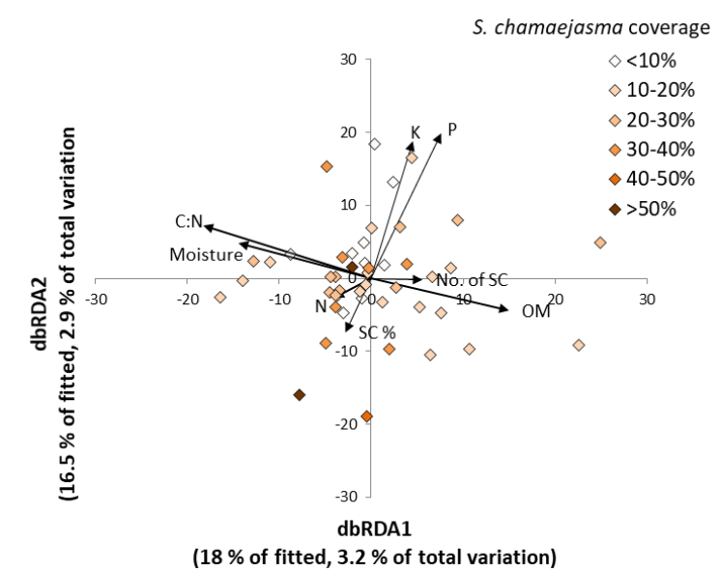
Figure 6. dbRDA plot of global fungal communities in the invaded site (quadrats) relating variations in fungal populations with soil and S. chamaejasme cover and abundance. Invaded site only. Nutrient, moisture and organic matter are % total (C = carbon, N = nitrogen, P = phosphorous, K = potassium, moisture and OM = organic matter). SC = % cover and abundance of S. chamaejasme per quadrat.
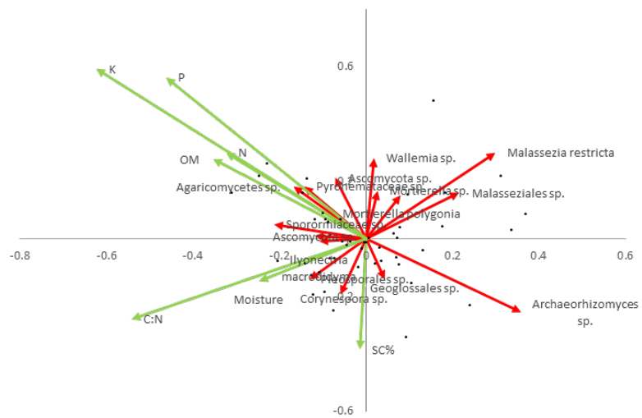
Figure 7. Redundancy analysis triplot of fungal species relative abundance (red) and potential predictive factors (green) for invaded site only. Includes only those species most strongly correlated with the primary axes. Nutrient, moisture and organic matter are % total (N = nitrogen, P = phosphorous, K = potassium, moisture and OM = organic matter). SC% = % cover

Conclusion: This study indicates that lower fertility soils may be more susceptible to invasion by S. chamaejasme. Although the influence of S. chamaejasme on total fungal community composition was limited, there was evidence of effects on particular fungal species. Further research is needed to determine whether these effects influence S. chamaejasme invasiveness. (for a full research paper please be referred to “Microorganisms, 2019, 7(12), 587”)

Host genotype and precipitation shape influence fungal endophyte symbiosis and mycotoxin abundance in a locoweed
Background: Many plant endophytes produce mycotoxins, but how host genetic variation influences endophyte colonization and mycotoxin production under natural conditions is poorly understood. This interaction has not been fully considered in many previous studies which used controlled experiments with agronomic or model plant species. Here, we investigated this interaction in a naturally occurring forb (a locoweed species) Oxytropis ochrocephala, its symbiotic endophyte Alternaria oxytropis and the mycotoxin swainsonine. O. ochrocephala is a perennial native forb widely distributed in western China. It forms a symbiotic interaction with the endophytic fungus, A. oxytropis, which produces the toxic alkaloid swainsonine making the plant poisonous to sheep and horses.
In this work, we consider how O. ochrocephala has evolved, and whether host genotype influences endophyte colonization and mycotoxin production in naturally evolved populations. Additionally, we consider how environmental variables could be an important additional determining factor. Thus, we quantified plant genetic variation, endophyte infection rate and mycotoxin concentrations in the wild Chinese forb O. ochrocephala from sites across western China.
Methods: Leaf material of O. ochrocephala samples were collected during the flowering season of July to August from 33 localities across five provinces in China in 2012, 2013 and 2014. In total 368 individuals were sampled. Fourteen polymorphic and reproducible primer sets were selected and used for genotyping. Swainsonine concentration was measured for each accession and endophyte infection rate determined.
Results: We have the results as follows:
- Two clusters which are genetically divergent were characterized in the 33 accessions (Figure 1). Analysis of molecular variance showed that most of the variance could be attributed to within-accession variation (Table 1). Genetic variation at the three hierarchies were all significant. Fst suggested that both mixed breeding and clonal strategies are employed.
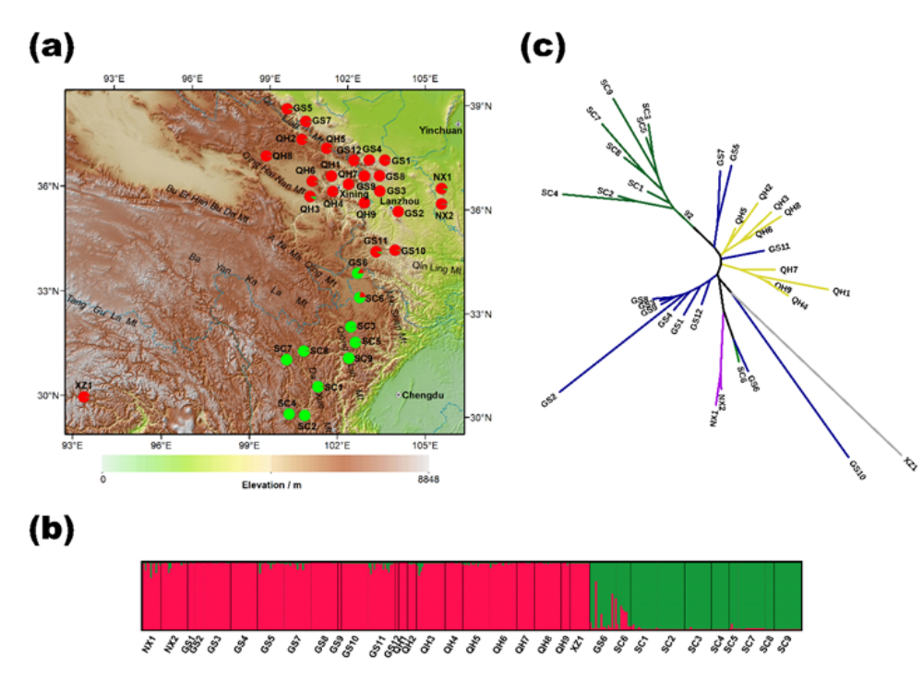
Figure 1. Genetic variation and differentiation in the 33 O. ochrocephala accessions in western China revealed by 14 SSR loci. Accession code can be referred to in Table A2. (a): Histogram of the STRUCTURE genetic assignment of the 33 accessions. (b): Geographic origin of the 33 accessions and their color-coded genetic partitioning at the most likely K (=2). Red and green colours correspond to the genetic assignment by STRUCTURE (in panel b). The horizontal length of each colour represents the probability of the individual within that cluster. (c): Neighbor-joining dendrogram of the 33 accessions. Different colours of the branch indicate samples collected from the five provinces.

Table 1. Analysis of molecular variance (AMOVA) for O. ochrocephala at fourteen SSR loci at the following hierarchy: (1) amongst the two populations identified by STRUCTURE analysis; (2) amongst the 33 accessions within the two populations; and (3) within accessions.
Source of variation | d.f. | Sum of  squares | Variance components | Percentage of variation | Fixation  indices
Amongst populations | 1 | 173.928 | 0.505 Va | 9.69 | Fct=0.0969***
Amongst accessions within populations | 31 | 757.888 | 0.937 Vb | 17.95 | Fsc = 0.199***
Within accessions | 703 | 2653.730 | 3.775 Vc | 72.36 | Fst = 0.276***
Total | 735 | 3585.546 | 5.217 | 100
Asterisks (***) indicates significant value (p<0.001)
- There is no significant difference in endophyte infection rate in population 1 (34.5%, n=20) and 2 (30.5%, n=10), but swainsonine concentrations differed significantly (0.0166‰, n=20 in pop 1 and 0.0026‰, n=10 in pop 2) (Figure 2).

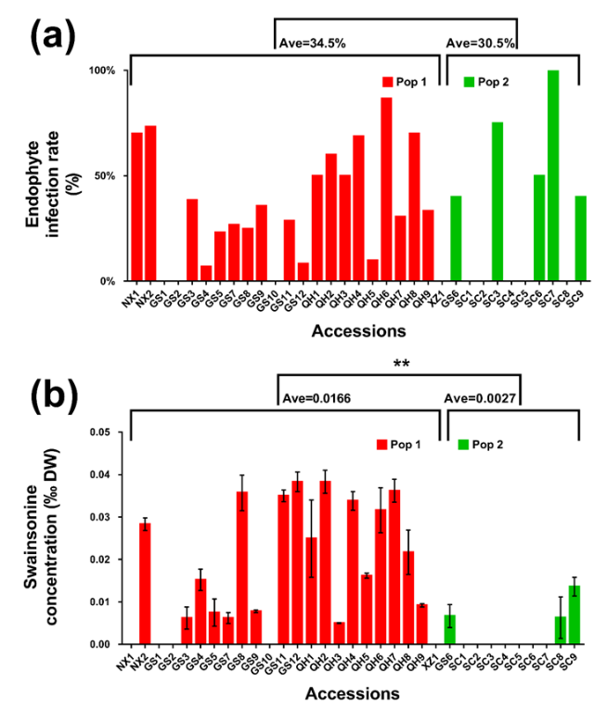
Figure 2. Endophyte (Panel a) and swainsonine (Panel b) concentration in 33 accessions of O. ochrocephala. Pop 1 (population 1) represents accessions from Ningxia (NX), Gansu (GS, except GS6), Qinghai (QH) and Tibet (XZ) and pop 2 represents accessions from Sichuan (SC) and GS6. Bars represent mean ± SEM in panel b). Asterisks indicate significant difference.

- Host genetics were significantly correlated with geographical location, elevation and precipitation (Table 2). This demonstrated the effect of isolation-by-distance and altitudinal environmental variation on the genetic divergence seen in the two populations of O. ochrocephala. The correlation coefficients between annual precipitation and genetic distance (r=0.4836, p<0.001 and n=528 pairwise), population partition (r=0.584, p<0.001 and n=33) and clustering (r=0.762, p<0.001 and n=332) were significant at each level of genetic hierarchy. Thus, we suggest that precipitation plays a key role in driving plant genetic divergence in O. ochrocephala (Figure 3).
Table 2. Environmental effects on plant genetic divergence.
 |  |  | Genetics
 | Elevation |  | Genetic distance | Population partition | Cluster | He
Geographic distance | --- |  | r=0.523*** | --- | --- | ---
Elevation | --- |  | r=0.424*** | r=0.621*** | r=0.662*** | r=0.010
Annual precipitation | r=0.730*** |  | r=0.484*** | r=0.584*** | r=0.762*** | r=-0.256
Annual temperature | r=-0.489** |  | r=0.258* | r=-0.067 | r=0.049 | r=-0.371*
He: expected heterozygosity (Table A2); Population partition: the percentage of pop 2 from the Structure analysis; Cluster: nominal 1 & 2 as pop 1 and 2. Asterisk (*, * * & ***) indicates significant value (p<0.05, p<0.01 and p<0.001). The same applies in Table 3.

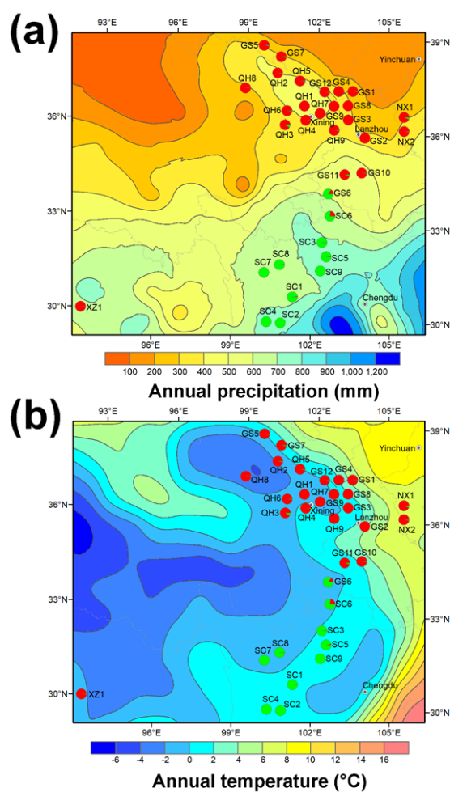
Figure 3. Annual precipitation (a) and temperature (b) in the 33 O. ochrocephala accessions and their genetic partition by Structure.
- In terms of endophyte colonization, the data showed that at the accession level, host genetics and environment are not correlated with the endophyte infection rate of A. oxytropis (Table 3). Chi-square test of the distributions of the four types of endophyte/swainsonine combination (Endo+ Toxic+/ Endo+ Tox-/ Endo- Tox+/ Endo- Tox-) are not equal in the two populations (p=0.0095). This suggests that in the two populations, the ability to produce swainsonine by endophytes may shift towards being more stochastic in pop 2.

Table 3. The Genetics (G) x Environment (E) effect on (and) endophyte symbiosis and (on) swainsonine content.
Factors |  | Endophyte infection rate | Swainsonine content
G | Genetic distance | r=0.157* | r=0.218***
G | Population partition | r=0.014 | r=0.492**
G | Cluster | r=0.136 | r=0.570**
G | He | r=0.020 | r=0.377*
E | Geographic distance | r=0.093 | r=0.340***
E | Elevation | r=0.001 | r=-0.197
E | Annual precipitation | r=-0.261 | r=-0.444*
E | Annul temperature | r=0.008 | r=-0.096

- As the host diverged, the symbiotic interactions were reduced or failed to produce detectable swainsonine in one host population. Host genotype and precipitation had a significant impact in shaping swainsonine production at the population level (Figure 4).
- Conclusion: For our model system, we hypothesize that host genetics act on sorting swainsonine producing endophytes with wider impacts on the entire endophytic fungal community. Such information can be integrated with environmental data and mycotoxin levels for effective identification of genetic loci governing the interaction of hosts and endophytes. (for a full research paper please be referred to International Journal of Molecular Science, 2019, 20(21), 5285)
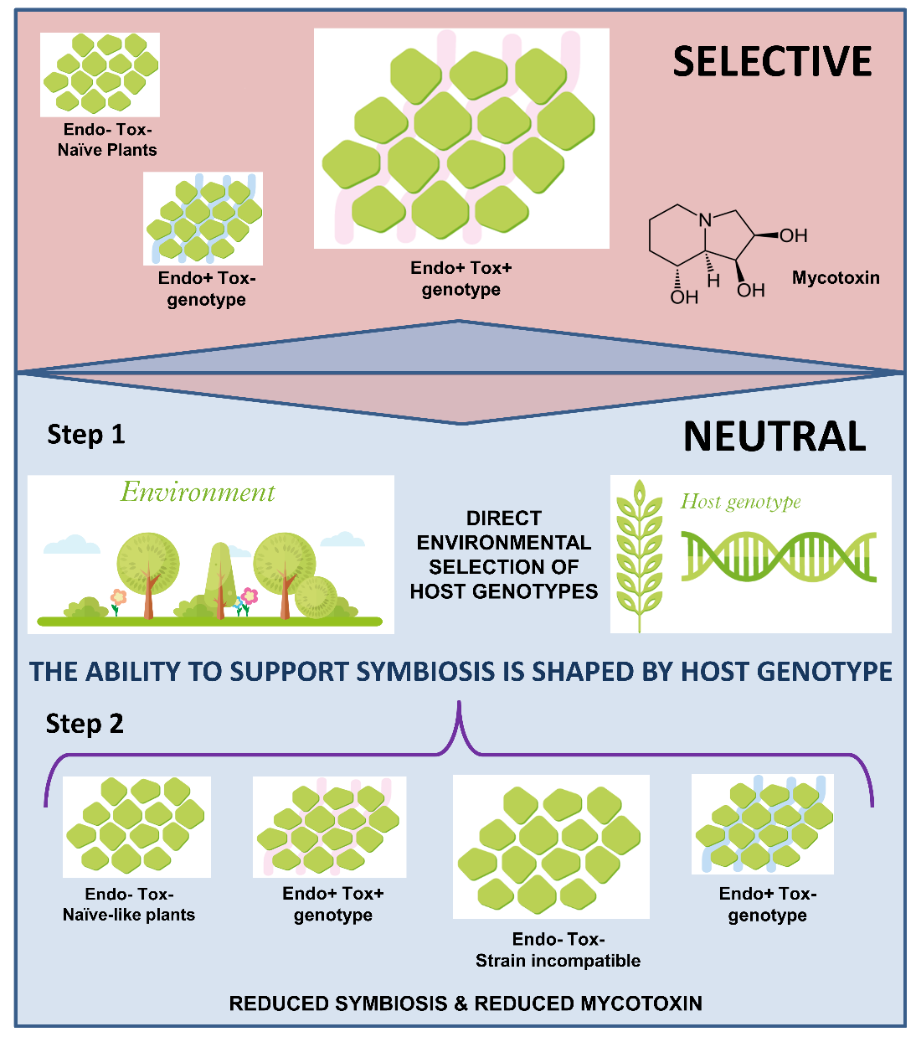
Figure 4. Hypothesized model of G x E (gene and environment) interaction on endophyte symbiosis and mycotoxin synthesis using the current study as an example. The green clumps represent plant cells. Endophyte free plants are represented as “Endo-”. Non-toxic endophyte strains are represented by blue lines (Endo+ Tox-) and toxic endophyte (Endo+ Tox+) by red lines in between plant cells. The “Selective” scenario represents an ancient symbiosis, in which naïve plants were colonized by toxin producing endophyte strains. The endophyte can also evolve and lose the ability to produce mycotoxin, forming “Endo+ Tox-” symbiosis. Presumably plants with mycotoxin have a selective advantage at this stage of evolution, and the “Endo+ Tox+” plants were dominant in the population, as demonstrated in population 1 in O. ochrocephala. As the host plant has evolved, environment has a direct selective effect on plant genetic variation. As a result, the ability of host plant to support endophyte symbiosis is shaped by this genotype incompatibility. In this “Neutral” scenario, since toxic plants do not have selective advantages anymore, symbiosis is lost in accumulative generations. Consequently, the dominant “Endo+ Tox+” symbiosis is tuned down, as reflected in population 2 in the current study. The abundance of each type of plant with/without endophyte symbiosis is reflected by the size of the type of cell clumps. It should be noted that evolutionary changes could reverse from neutral to selective effects and vice versa.

Characterization of the effective antiseptic and insect-proofing compounds in grass Stellera chamaejasme L.
Poisonous grassland weeds in China cause problems in ecosystem and animal husbandry. Effective controlling methods have to be developed, but on the other hand, it provides plant material for possible utilization purpose. For example, many of those weeds contain plant toxins of other metabolites which are potential recourses for germicides, insecticides and herbicides.
Based on our investigation, S. chamaejasme is one of the most adaptive poisonous weeds across China. S. chamaejasme, as a grass, has a very deep root system and the roots are lignified, and historically, the plant has been used as a feedstock for papermaking in Buddhism scriptures in Tibet. Paper made of S. chamaejasme is antiseptic and insect-proofing, but currently, the effective compound(s) is still unknown. In the Mur Lab, a high throughput platform has been established for efficient screening of anti-microbe metabolites from plants and cytotoxicity based on mammalian cell cultures and I intent to use the platform to identify the effective antiseptic and insect-proofing compounds in S. chamaejasme.
S. chamaejasme aboveground (leaves) and underground samples (roots) were collected from Qinghai Province, China. The samples were ground and sieved (mesh number 200) from debris. Twenty five microgram of the leaves and roots material were used to assess the antimicrobial activity. In the following experiment 250 mg material was used. Samples were weighed and extracted with 100% methanol until the extract is clear of colour. The extracts were combined and dried on a rotavapor. The crude extract was then dissolved in methanol: H₂O (50: 50 V/V) and extracted sequentially with hexane, dichloromethane (DCM), acetyl acetate and H₂O. Each fraction was dried on a rotavapor and then freeze-dried for antimicrobial activity test. For each fraction, a 2-fold dilution series starting with final concentration of 250 µg/ml was added to overnight bacteria cultures containing strains of E. coli, PA, SA, MRSA and T.B. Absorbance were measured at 0 and 24 h to calculate the inhibition ratio on a spectrophotometer. Since leave material did not show activity against those pathogens, they were excluded from the following experiment.
Since the DCM fraction from the root extract showed the most antimicrobial activity, it was subjected to further purification including 1) flash chromatography purification and 2) column purification. Two sub-fractions No. 21 and No. 23 showed the highest antimicrobial activities and were further characterized by LC-MS and NMR.
We identified two pure compounds specifically against SA and MRSA. An initial configuration by MS suggested that one compound belongs to flavonoids (please understand the information is still confidential for publication purpose at the moment). We are still waiting for NMR confirmation.

MoU between Aberystwyth University and Northwest University
Prof. Luis Mur and I successfully help both universities sign official Memorandum of Understanding to strengthen future collaboration in biological sciences. We were able to see some success from the MoU in:
- Prof. Luis Mur visited Department of Biology, Northwest University in September 2018 and gave two presentations to the staff and students. He was also awarded Visiting Professorship from Northwest University.
- Prof. Luis Mur visited Tibet in December 2019 by the company of Dr. Wei He to discuss ongoing project and future collaboration.
- Ph. D candidate Duo Cao in Dr. Wei He’s group was awarded an exchange grant from the Chinese Scholarship Council (CSC) for a period of 12 months to sponsor her studies in Aberystwyth University in 2019 to Prof. Luis Mur’s group.
- I secured a three-year exchange programme sponsored by the CSC to support three staff/students to visit Aberyswyth University from 2019.

Conference and other visits
I was invited to attend the conference “Governing Trust in the Biosciences: Institutional and Cultural Change” at the British Academy in February 2018. This was the concluding conference of the ESRC project “Governing Accountability in China's Life Sciences” led by Dr. Joy Zhang at Kent University. I also gave a talk and chaired one session.
I also visited Prof. Ian Graham’s group at The University of York and gave a talk about the research work I had been doing.

- Financial statement
The total amount of 6500 pounds were used according to the budget plan as in the application form.

- Acknowledgement
I am grateful to The Stapledon Trust for the sponsorship to support my visit to Aberystwyth University. The collaboration we have built with Aberystwyth University will continue to benefit grassland related research.

