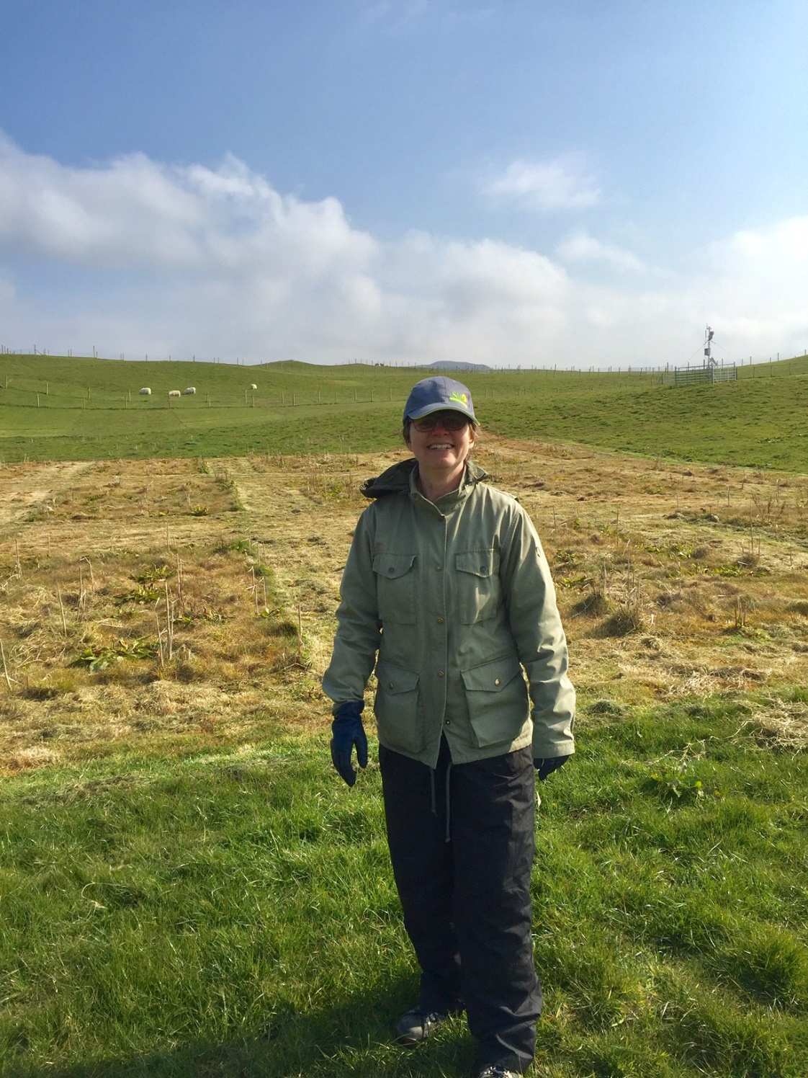

Energy grass research in Wales and Sweden

Cecilia Palmborg and Elaine Jensen

Report to the Stapledon Memorial Trust of a research visit

Department of agricultural research for northern Sweden
Swedish University or Agricultural Sciences
90183 Umeå
Sweden

Research and fellowship dates – 1st April 2019– 1st May 2019

UK lead and host organisation
Institute of Biological Environmental Rural studies (IBERS)
Aberystwyth University
Gogerddan
Aberystwyth
Ceredigion
SY23 3EE

Contact at UK lead organisation
Dr. Elaine Jensen, Senior Grass Breeder, IBERS, Aberystwyth University. Email: fft@aber.ac.uk.

Summary of the fellowship
The fellowship was applied for to finance a trip from Umeå in Sweden to IBERS in Aberystwyth. The intention of the visit was to exchange information about cropping and demands of reed canary grass. In addition I learned about the research on MIscanthus ssp. in Aberystwyth.

Fellowship Background
Reed canary grass is a tall perennial grass that is native to Eurasia. It has been used as a forage species in Europe and northern America during the 20th century. In the 1980s it was noticed as an energy crop because of its high production potential and low nutrient demand in cropping. It has also been used in remediation of mine tailings in northern Sweden as a means to decrease the amount of water leaching through the tailings by increasing evapotranspiration {Neuschutz, 2010 #2874}.
Aberystwyth is near the central Wales orefield and thus has hundreds of abandoned local metal mines associated with metal mining of the last two centuries. Wales has 67 surface and groundwater bodies failing under the Water Framework Directive due to pollution from such sites. Of the 1300 abandoned metal mines in Wales, funding restrictions limit Natural Resources Wales to tackling problems at 10 such sites, due to the high cost of conventional engineering solutions (£800K-£2.5 M per site). Metal mine pollution sources are distributed via sediment transport, leaching and/or mine water drainage. Landowners require low-cost solutions that can be applied responsibly across a range of sites. Dr Palmborg has extensive experience in the perennial grass RCG, including in metal uptake by this species, and will help Dr Jensen build on her phytostabilization approach at a preliminary trial site near Aberystwyth. This work will test the potential of RCG to reduce metal salt leaching through increased evapotranspiration, reduce run-off through canopy interception, and reduce erosion through spoil stabilization.
The aims of this visit was to continue collaboration started in the EraNet-funded ORNATE project (Optimization of reed canary grass as a native European energy grass), completed in August 2017, by:
Three tasks were planned to be performed
1) finalizing publications from the aforementioned project,
2) developing IBERS’ knowledge of Phalaris arundinaceae (reed canary grass, RCG) as a phytoremediation/phytostabilization species, and
3) reviewing options for further funding to expand the utility of this species.
Additional research communication activities
4) holding a seminar with the aim to exchange research experiences using reed canary grass as an energy crop in northern Sweden and in Wales.
5) holding a more general seminar presenting reseach on use of digestates from biogas plants as fertilizers for different agricultural crop.
6) study visit to Center for Alternative Technology in Machynlleth was made, with the aim to study how sustainable energy systems are presented to the public in an appealing environment.
Activities undertaken during the visit
Writing of scientific paper
A manuscript titled “Reviving reed canary grass (Phalaris arundinaceae) for sustainable bioenergy: a fresh look at yield potential and quality traits using novel germplasm” was prepared. A lot of time was spent on comparing methods and datasets from the Swedish and Welsh projects. Also some statistical analyses had to be remade. But all in all the manuscript is well on its way and we also have prepared for two more manuscripts.

Phenotyping of Miscanthus
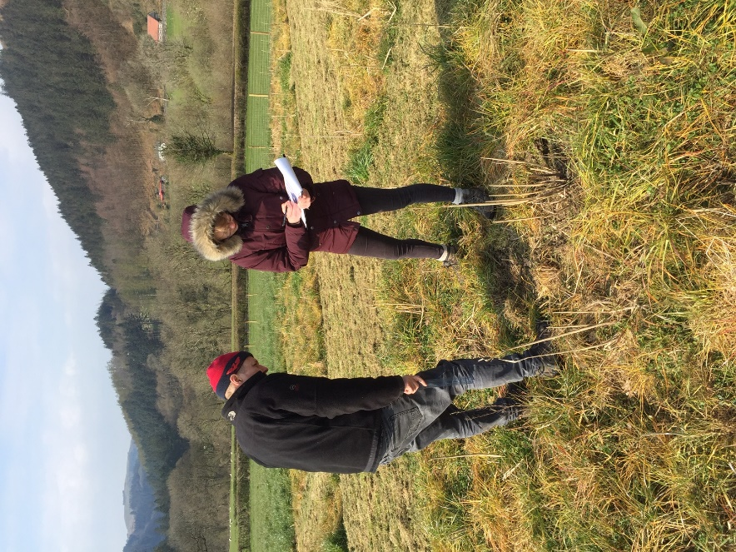
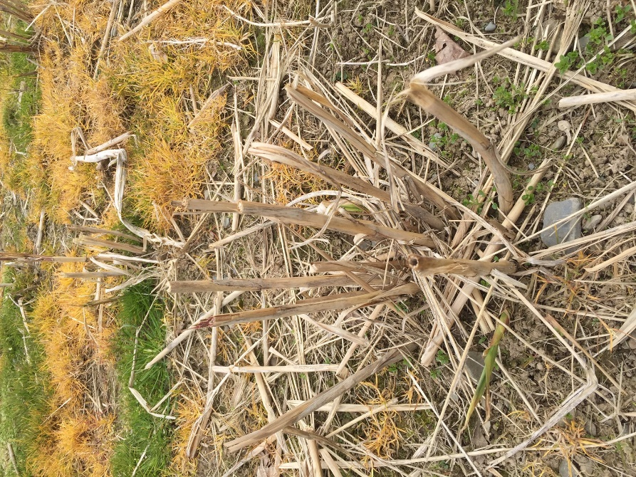My colleagues in phenotyping Sprouting Miscanthus
The Miscanthus group in Aberystwyth has developed different hybrids of Miscanthus that can be propagated with seeds. These have been planted at four different sites following an elevation gradient in the highlands of Ceredigion. At each site 40 plots had been planted with 35 plants of a specific hybrid. Three of the plant in the middle row were e valuated for each plot. This was the first phenotyping made in a series undertaken every other week. Each site also had a weather station recording temperature, precipitation and wind speed. These data are going to be used to select the best hybrids for different climatic conditions, and also estimate their production potential in different environments.
I followed two technicians on the first phenotyping tour of the season to these sites. I was noting the presence of new shoots and the height of the longest new shoot was measured. The percentage of frost damage was also estimated.
On the most elevated site the plants had just about started growing and many of the hybrids had few or none emerging shoots. The most productive site seemed to be the third site that was situated on a hill above a valley where the bottom site was situated. The reason for this is probably that cold air tends to go down the bottom of valleys during frost nights.

Visit to an abandoned mine site.
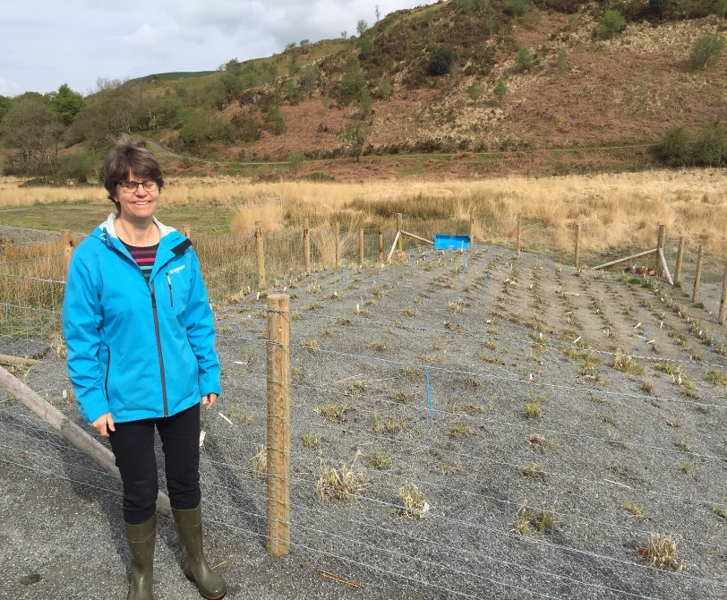
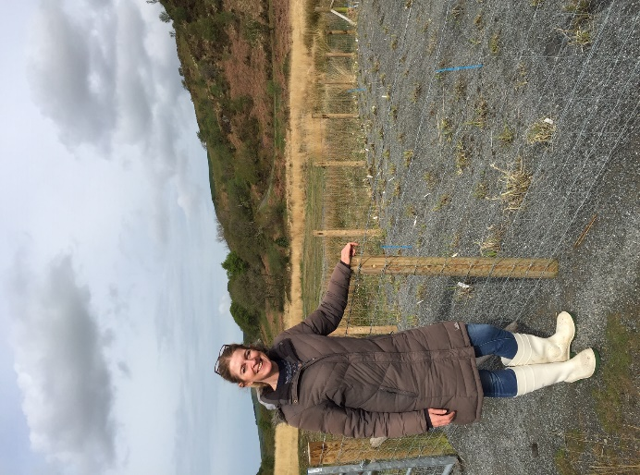
Me at mine site Elaine at mine site
On the abandoned mine site xxxxx, reed canary grass and Miscanthus had been planted on some mine tailings. The material in the tailings was gravel mixed with silt and clay. The more clayey material was more contaminated. In the planting spots, about one cubic decimeter of tailings had been replaced by a mixture of 2/3 compost and 1/3 of tailing on a volume basis. Else the plants were not fertilized. The plants were all small and had not spread much from the original planting spot. Some differences between accessions could be seen. It also seemed that reed canary grass had started spreading from the planting spot, while Miscanthus had not. We discussed the uptake of metals in the harvested biomass, that had been surprisingly high the year before, and the possibility to use plants to extract metals from soil as a kind of environmental friendly mining. We also discussed the possibility of using the plants already present at the site for remediation purposes.
Open lecture at Aberystwyth University
A lecture open to both students and researchers was held at Aberystwyth university, IBERS, Penglais campus on 8th of April 2019. The title was” Digestates as fertilizers to barley and grass/clover”. Results from a three year project in northern Sweden and Finland were presented. The talk led to an interesting discussion about nutrient cycling within agricultural systems and between rural areas and agriculture.
Presentation to the Miscanthus group at Gogerddan campus.
In the regular lunch seminar series of the Miscanthus group of IBERS I gave a seminar given with the title: Reed canary grass development projects financed by the Swedish energy board. One of the projects was ORNATE, the project where I had collaborated with IBERS. The other project was “Reed canary grass-in depth studies of varieties” In this project, data from 20 years of reed canary grass variety trials had been meta-analysed to find that several of the varieties had higher yields than the commercial variety Bamse. Also comparisons between different harvest systems had been made both in northern and southern Sweden. The presentation was followed by a lively discussion about different cropping systems and differences between Wales and Sweden regarding soils and climate. Also the pros and cons of different methods to study cell wall composition of plants were discussed, since the chemical analysis data that had been performed using material from the ORNATE project showed unexpectedly high lignin content in the youngest grass material.
I also participated in two seminars given by people in the Miscanthus group and I was impressed by the open and lively research discussions.

Study visit to CAT (Centre for Alternative Technology).
The study visit was made on the Easter Sunday as an ordinary visitor to centre.
In the centre a broad variety of alternative technologies for everyday life were presented. Transport: the cliff railway is propelled by water filled into the train going down that is connected to and lifting the train going up the cliff.
Food production: methods for home gardens such as composts, plantations beneficial for butterflies and bees and mulches were presented in a very compelling and attractive way. A forest garden also showed how a natural ecosystem can be a model for sustainable food production.
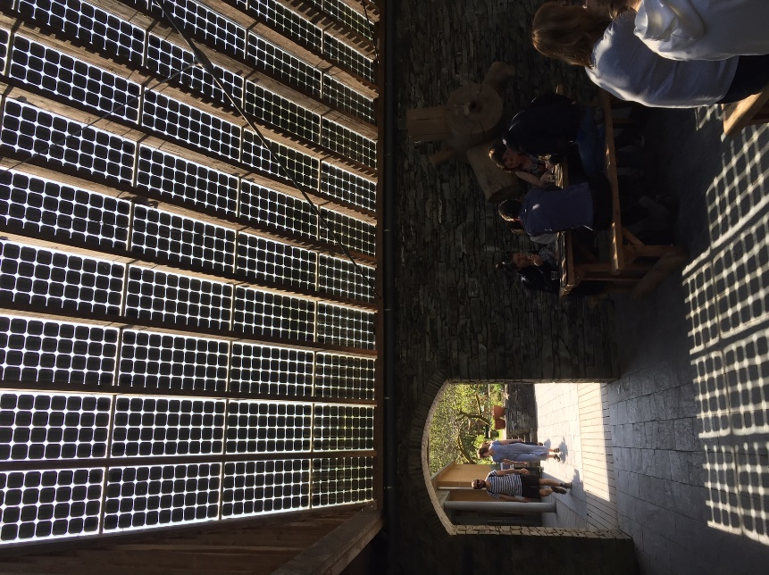
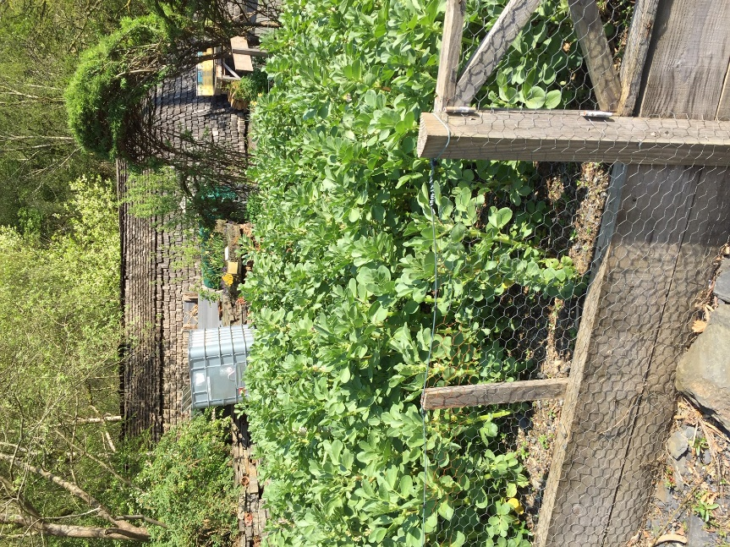
Dining area shaded by solar panels Faba beans at CAT
Food consumtion: The restaurants served vegetarian and vegan food and informed about the lower carbon footprint of such diets.
Housing: Several construction methods using local material had been used for the buildings in the area. Some of the methods were also shown in a build area where schools and visiting groups could get hands on experience in building using clay, straw and other natural materials.
Heating: Heat pumps, solar water heating, biomass burning on both household and district heating scale were demonstrated and also used in the buildings of the centre.
Electricity: Solar panels, wind power and micro-hydroelectric plants were used and displayed. In one very pedagogic display the electricity output from a solar cell was shown and shading the panel instantly changed the output.
Bioenergy crops. Miscanthus and Reed canary grass were grown in connection to the other energy displays.
Waste treatment. A compost toilet that also takes care of kitchen waste is displayed and also flushing toilets that separate liquids from solids and compost the solids away from the toilet site.
My overall impression is that it is very pedagogic that the centre not only displays the different technologies, but they are used in the construction and running of the facilities and that the public even can take part in the creation and maintenance of the centre.

Benefits of the Fellow
It was stimulating to learn to know another scientific environment and the methods used in Miscanthus research. The open discussions at seminars and at teatime were interesting and the staff at IBERS really made an effort that I should understand even though I knew very little about Miscanthus from the start. It also was inspiring to see all the efforts that a densely populated country as the UK make in conversion to a sustainable energy system.
My reflections on the comparison between Miscanthus and reed canary grass is that using Miscanthus has a lot of benefits such as high production and low fertilizer demands. However Miscanthus can so far only be grown in the warm temperate zone, not in northern Scandinavia. There can also be other restrictions in what environment are suitable such as low pH and high heavy metal content in mine spoils. In some of these environments reed canary grass could be a viable alternative.
Benefits of the host organisations
The staff at IBERS got to learn about reed canary grass and its nutrient demands. They got help in understanding possible reasons for the results from the experiments made with reed canary grass in Wales. The fertilization levels in the Welsh experiments were much lower than the levels used in Sweden. This caused the production levels to be low, but there were differences between RCG accessions in their ability to produce biomass at these low fertilization levels. Thus suitable accessions for the Welsh conditions could be identified, but further research is needed to assess the long term viability of the most promising accessions, especially for green harvest.
The seminar held about use of digestate in agriculture in northern Sweden influenced the submission of an application for a research grant by John Clifton Brown.

