A Report to The Stapledon Memorial Trust
Flooding tolerant forage grasses for Welsh flood prone valleys.

Period of fellowship: 17th June – 26th July 2019

Student: Rachel Dye Email: rad35@aber.ac.uk
Supervisor: Sarah Palmer Email: sap42@aber.ac.uk

UK Lead Organisation:
Institute of Biological Environmental Rural studies (IBERS)
Aberystwyth University
Gogerddan
Aberystwyth
Ceredigion
SY23 3EE

Projects I was a part of:

Over the six-week period of working with staff at IBERS I was able to observe and take part in the processes involved at all stages of the plant breeding cycle from sowing to harvesting. Before researching around my chosen topic, I was familiarised with the conventions of the procedures used to breed forage grass at IBERS. This was fundamental to the way I would plan my own research as it enabled me to gain the required skills in plant care, data analysis and a greater understanding of specific methodologies.

In many projects I was involved with the sowing, this involved taking seed (stored at the facility seed store) and sowing into trays with one seed per well. After seedlings had emerged a process called thinning is carried out where any extra seedlings in wells are removed so that there is only one per well. This is important as qualities are tested within individuals, so it is required that they are separated. I also weighed out seed for national list trials for clover and forage grasses.

Another process I was able to be a part of was the inoculation of crown rust on forage grasses, this was interesting as I was able to gain knowledge of the relevant conditions for optimal spread of pathogens. Trays were moved into a controlled environment room and sprayed with crown rust and left to be infected. Rust scores can then be conducted to conclude which individuals show disease resistance.

There were many other tasks to complete that allowed me to understand the way in which breeding cycles and treatments are handled at IBERS which proved helpful to my own project.

My Project:

Introduction:

The project I wish to obtain background knowledge is to test for flooding tolerance in forage grasses.
Flood tolerance is an important trait to breed for as the change in climate leaves for an uncertain future for agricultural conditions. It is therefore beneficial to be researching flood tolerant lines now in order to prepare for years where flooding will be more frequent. In a recent statistic published by NASA, global temperature has risen by 1.9F since 1880, which is faster than any previously recorded temperature change (Climate Change: Vital Signs of the Planet, 2019). Giving rise to more fluctuating weather patterns such as increased rainfall (GOV.WALES, 2019).

In the most recent monthly water situation report by the Environment Agency, the regional rainfall totals were above average or higher in all regions, this is the fourth consecutive month where rainfall has been higher than average (GOV.UK, 2019). In Lancashire the September rainfall totals were the fourth highest on record (records from 1891) (GOV.UK, 2019). By the end of September soils were wetter than average (GOV.UK, 2019). Within wales 0.87m Ha of the 1.75m Ha of utilised agricultural land is situated in flood prone areas, 43% of which is improved grasslands (0.38m Ha) (GOV.WALES, 2019).

It is therefore important to conduct more research into the effects of flooding on grasslands and develop tolerant lines able to withstand periods of flooding and waterlogged soils. I would aim to test different lines of perennial ryegrass (Lolium perenne) and Festulolium (where fescue has been combined with Lolium perenne) for waterlogging tolerant qualities. Previous work has shown that Festulolium lines have rooting qualities that make them more tolerant to flooding but also in helping break the soil to improve drainage (Macleod et al., 2013).

Summer Work:

While working over the summer I was introduced to individual lines that had displayed tolerance to flooding in the past. These plants had an unknown origin, this was a task I was able to complete over the summer. I completed this by conducting PCR on samples of each of the unknown individuals in order to amplify the DNA. Alleles of the offspring were compared to those of possible parents, if alleles matched, they were listed as the parents of that individual offspring. Only four of the offspring had clear parents from the list. Two of these parents were selected for seed trials to observe if the parents are tolerant to flooding at an early stage.

In addition to this I was able to prepare plants for flooding by creating a randomised block design using Genstat software. This was done to maintain control in the experiment, seven of each of the lines grown from seed were chosen, there were three randomised repeats. The table below shows the lines and varieties that were chosen for flooding.

Table 1: List Displaying the Chosen Lines
Lines Grown from Seed:
Trojan | late diploid L.perenne variety
Ba14959 | intermediate diploid perennial ryegrass breeding lines
Ba14960 | intermediate diploid perennial ryegrass
AberZeus | intermediate diploid perennial ryegrass breeding lines
Ba14962 | intermediate diploid perennial ryegrass breeding lines
Galgorm | intermediate diploid perennial ryegrass variety
Ba14958 | intermediate diploid perennial ryegrass breeding lines
Ba14961 | intermediate diploid perennial ryegrass breeding lines
Ba14957 | intermediate diploid perennial ryegrass breeding lines
AberGreen | intermediate diploid perennial ryegrass variety
Ba14677 | intermediate diploid perennial ryegrass breeding lines
Lines Grown from Clone:
Ba9123 | Ecotype diploid L.perenne collected Turkey in 1971
Ba13240/5 | Ecotype diploid L.perenne collected Mendip hills 1996
Ba10170/6 | Ecotype diploid L.perenne collected Ireland kerry co 1981
Bx 514 | Festulolium accession L.perenne x F.glaucescens
AberWolf 1h | diploid L.perenne variety
AberWolf 2h | diploid L.perenne variety
AberNiche 11g | 4x Festuloium 90% L.multiflorum and 10% F.pratensis
SAP 11 2x | Selections from flooded containers
SAP 10 2x | Selections from flooded containers
SAP 9 4x | Selections from flooded containers
SAP 8 2x | Selections from flooded containers
SAP 7 3x | Selections from flooded containers
SAP 6 2x | Selections from flooded containers
SAP 5 4x | Selections from flooded containers
SAP 4 2x | Selections from flooded containers
SAP 3 2x | Selections from flooded containers
SAP 2 2x | Selections from flooded containers
SAP 1 2x | Selections from flooded containers

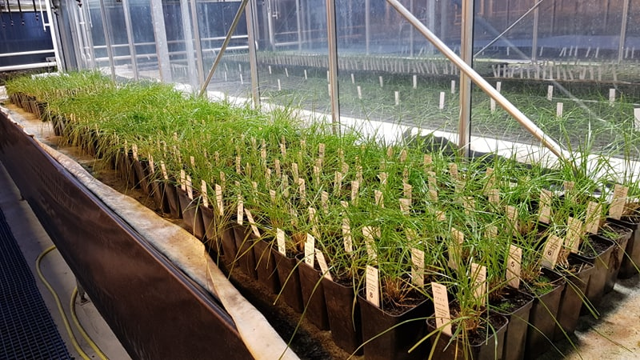
These had two harvests taken once they had established, this involved taking a cut 4cm from the base of the plant and placed into paper bags to record fresh weigh (g) and dry weight (after being placed in an oven overnight). The image below (Figure 1) shows plants before they are to be submerged.
Figure 1 - Plants Before Submergence
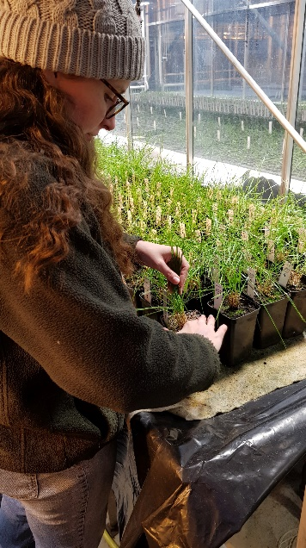
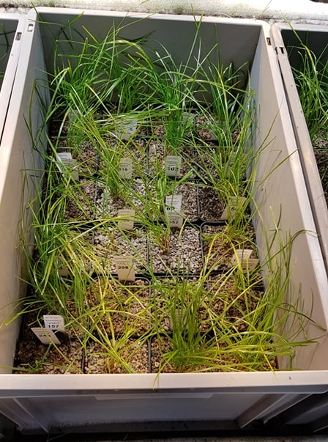
Figures 2 and 3 show the process of horticultural potting grit being applied (to prevent the dislodging of plants from the soil) and how the pots have been randomised into containers for flooding, respectively.
Figure 2 - Application of Potting Grit
Figure 3 - Individuals in Containers for Flooding

These will be flooded for three weeks before following work can be carried out. For these individuals that will include allowing them to recover and taking two more harvests to observe how plants survive post flooding.

Following Work:

To follow up on the work conducted over the summer period I will plan a dissertation research project around these plants which show waterlogging tolerance. This will be done by observing the effects that flooding the lines had whilst also setting up a supplementary experiment with seedlings to observe their characteristics regarding their flood tolerance. Results from seedling trials will indicate which lines are best suited to survival in waterlogged conditions, this is beneficial as it will allow farmers to sow during periods of more increased rainfall.

Future Considerations:

Before my experience at IBERS I had very little knowledge or experience regarding the cycle of plant breeding. Having completed my studentship I feel more inclined to choose this as a career choice as I am now planning on taking up a PhD at the organisation. I consider strongly that this will be my chosen career path, having at least some involvement in breeding of different plant species due to the confidence I gained over the summer.

Starting my dissertation now I feel as though I have gained adequate experience to be able to begin data collection as soon as I am able which sets me ahead of schedule. Another benefit to the studentship was that I had already made the connections with the relevant people for my dissertation work and was more easily able to contact them to discuss and set up my project when the time came.

I really enjoyed being a part of the many stages of plant breeding, this was valuable for me to see as previously I have only been exposed to the end product so this allowed me to see the breeding processes on a larger scale. I found conducting the parental analysis of the unknown individuals interesting as this was something I had never been exposed to before and was not very confident in carrying it out but once I understood the concept I enjoyed the process.

Overall my studentship was a very enlightening experience and one that I feel had prepared me for a future within this field. Not only has it prepared me but I feel confident to begin a career equipped with the basic skills I would require.

References:

Climate Change: Vital Signs of the Planet. (2019). Climate Change: Vital Signs of the Planet. [online] Available at: https://climate.nasa.gov/ [Accessed 14 Oct. 2019].
GOV.UK. (2019). Water situation reports for England. [online] Available at: https://www.gov.uk/government/collections/water-situation-reports-for-england [Accessed 17 Oct. 2019].
GOV.WALES. (2019). Home | GOV.WALES. [online] Available at: https://gweddill.gov.wales/docs/desh/publications/120126climateriskassessen.pdf [Accessed 17 Oct. 2019].
Macleod, C., Humphreys, M., Whalley, W., Turner, L., Binley, A., Watts, C., Skøt, L., Joynes, A., Hawkins, S., King, I., O'Donovan, S. and Haygarth, P. (2013). A novel grass hybrid to reduce flood generation in temperate regions. Scientific Reports, 3(1).

